CMP9767M – Foundations of Robotics

Lesson 12: Multi Robot Systems

Dr Gautham Das

Multi-Robot System (MRS)

Synonyms

* Robot team
* Robotic fleet
* Networked robots
* Robot swarms (Usually a special kind of MRS)

Higher level goals for the team

* Members coordinate and share task executions

**Single Robot / Multi Robots? – Example - 1**

A robot for helping humans?

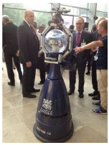

Or a group of robots for helping humans?

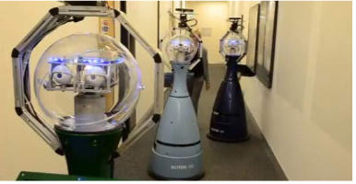

**Single Robot / Multi Robots? Example – 2**

Transporting a heavy object

Teaming up when a task cannot be performed by a single robot

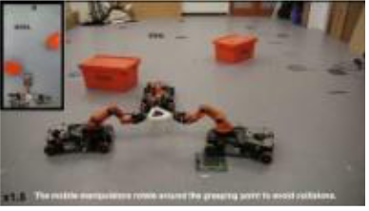

<https://www.youtube.com/watch?v=sDNqdEPA7pE>

Javier Alonso-Mora, Stuart Baker and Daniela Rus, Multi-robot formation control and object transport in dynamic  
environments via constrained optimization, The International Journal of Robotics Research, Vol 36, Issue 9, pp.  
1000 - 1021, August-10-2017, 10.1177/0278364917719333

**Single Robot / Multi Robots? Example – 3**

Spatially distributed tasks – Save time by working together

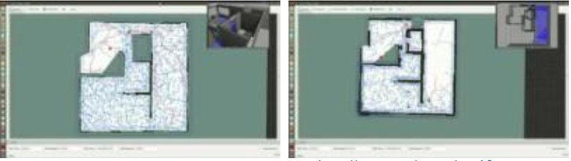

<https://www.youtube.com/watch?v=pZKmGst-E9U> <https://www.youtube.com/watch?v=x_5_BEpuJLY>

H. Umari and S. Mukhopadhyay, "Autonomous robotic exploration based on multiple rapidly-exploring randomized trees," 2017 IEEE/RSJ International Conference on Intelligent Robots and Systems (IROS), Vancouver,  
BC, 2017, pp. 1396-1402.

**Single Robot / Multiple Robots? Example - 4**

Complex task requiring different sensing / actuators

Collaborate by providing special services and blocks – Sensory data sharing, actuations.

These service blocks are linked to perform a task

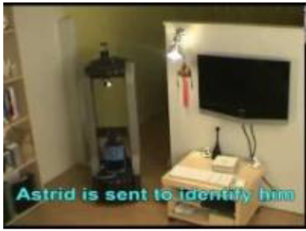

<https://www.youtube.com/watch?v=nV3YmoP0XJg>

Summary: Single Robot / Multi Robots?

Single robot

* Complexity
  + Integration Challenges
  + Too many actuators
  + Actuators blocking sensor
  + Computation
  + Power requirements
* High cost / robot  
  Can only be at one place

Multi-robot system (MRS)

* Each robot – less complex
  + Low integration challenges
  + With less no./without actuators
  + Carefully placed actuators
  + Less computation
  + Less power requirements
* Less cost / robot
* Can be at different places (spatial  
  distribution)

**MRS Classifications**

* Types of robots
* Homogeneous / Heterogeneous
* Inter-robot communication
* Active / Passive / No communication
* Decision making topology
* Centralised / Decentralised / Distributed
* Organisational paradigms
* Hierarchical / Federation / Coalition / Market
* Types of cooperative interactions
* Collective / Coordination / Collaboration / Cooperation

**Homogeneous / Heterogeneous robots**

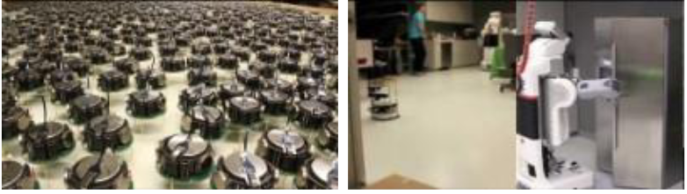

<https://www.youtube.com/watch?v=2IAluwgAFD0>

<https://www.youtube.com/watch?v=z36xkUILtQE>

**Decision Making Topologies**

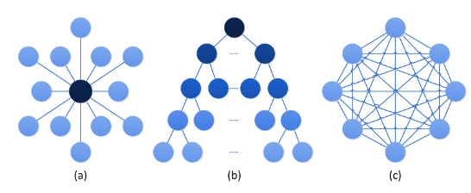

1. Centralised (b) Decentralised (c) Distributed

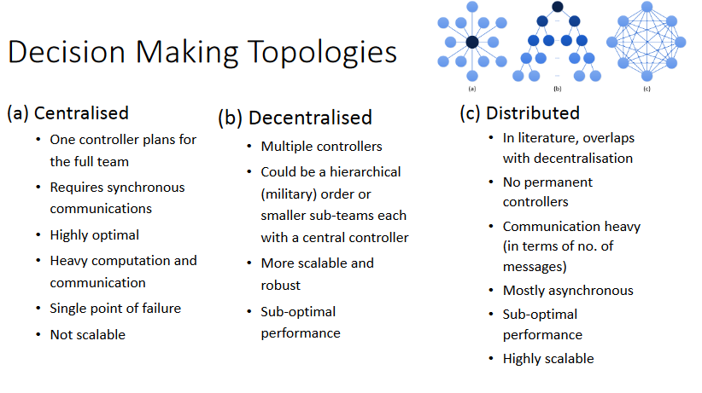

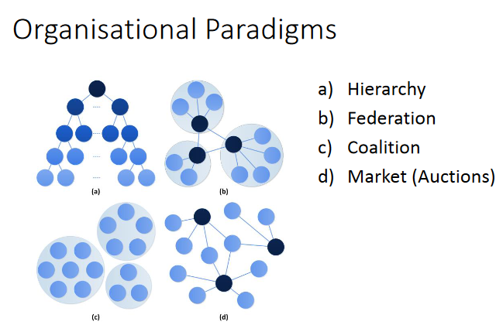

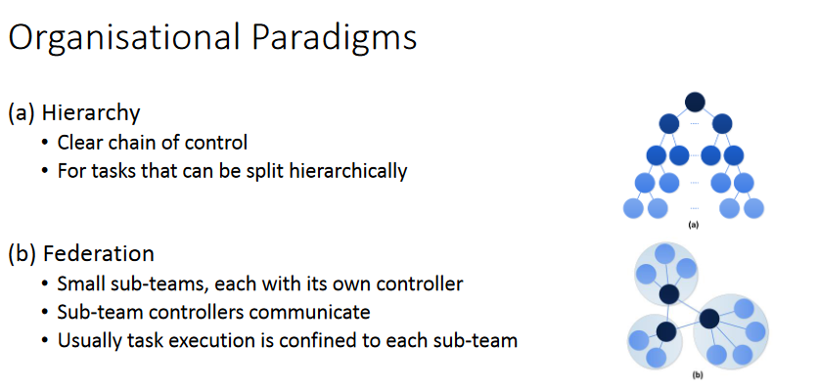

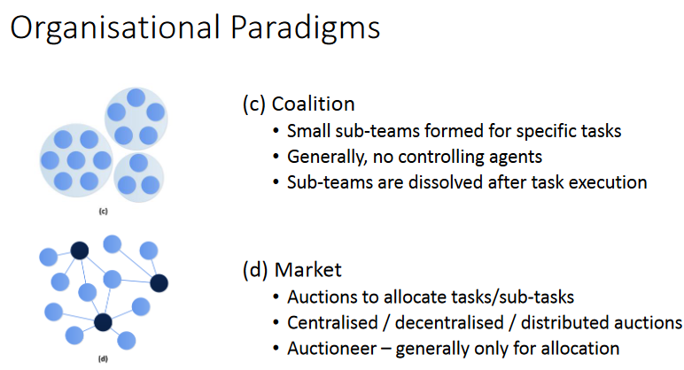

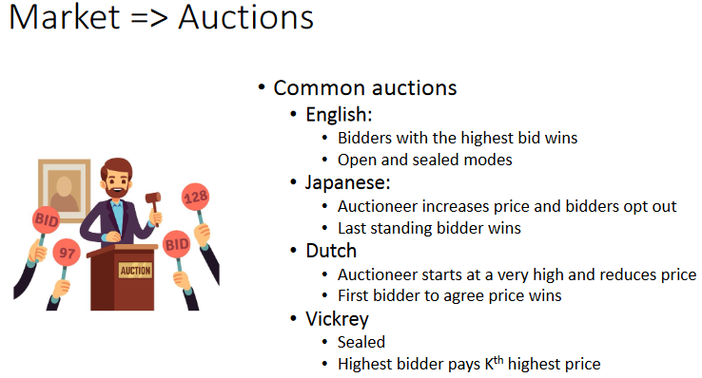

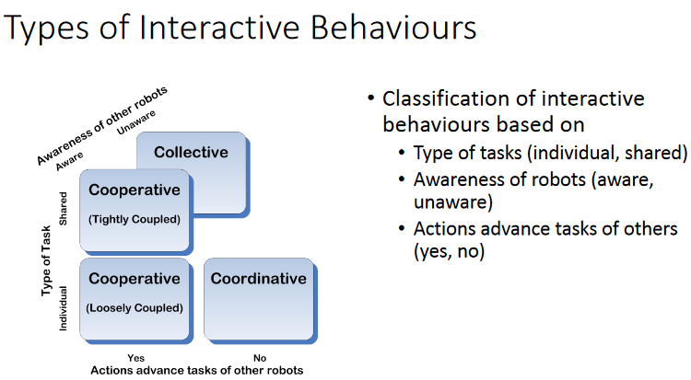

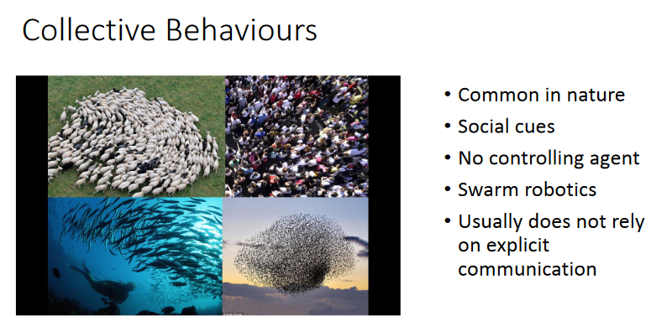

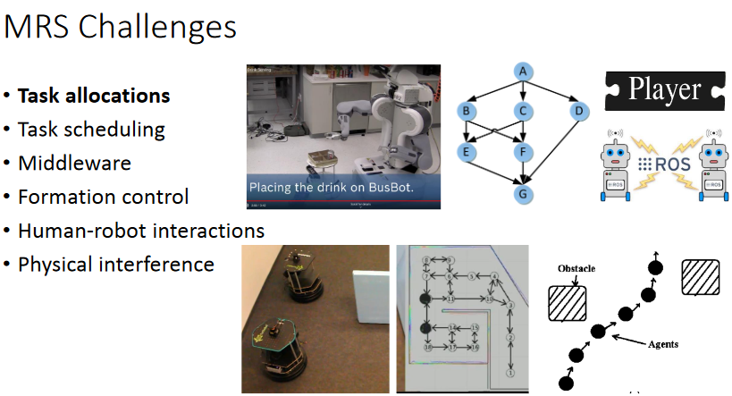

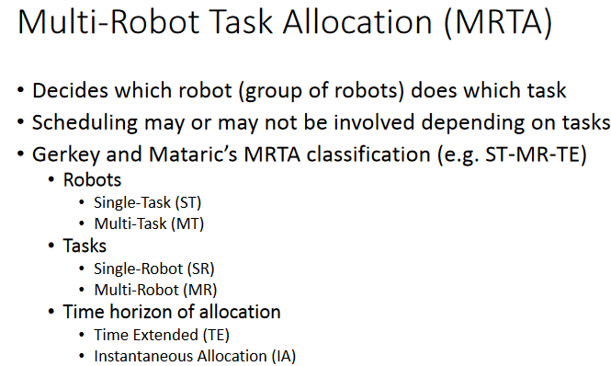

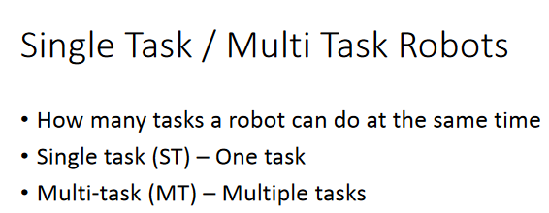

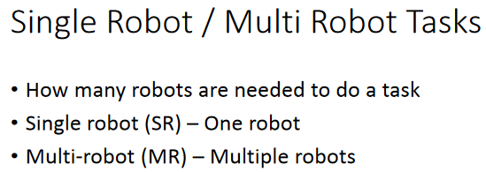A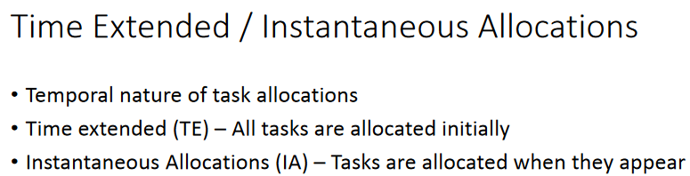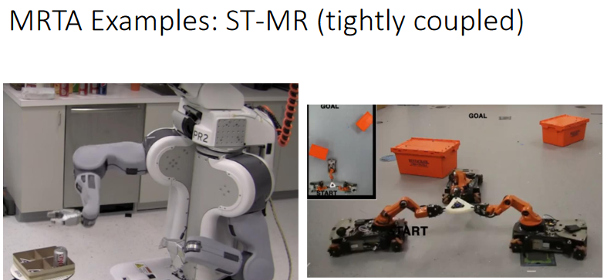

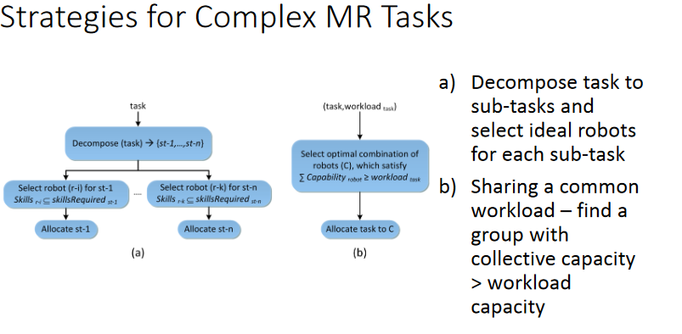

Conclusions  
• MRSs provide a robust option to tackle real-world problems  
•Useful for distributed tasks  
• Centralised – optimal but not scalable  
• Decentralised/distributed – sub-optimal but scalable  
• MRS, however, has many associated challenges  
• MRTA as a means to enable coordination